**Ski Trip, April 2023: Proposal for the Board of Directors**

**Proposed Dates:** 1st – 7th April 2023

**Proposed Destination:** Bormio, Italy

**Cost of Trip:** £1260 per student

**Aims of the trip:**

1. to learn a new adventurous activity in an outstanding alpine location.

2. opportunity for students’ personal development and character building.

3. to develop an understanding of, and appreciation for, a different culture.

**Tour Operator:** Rayburn Tours

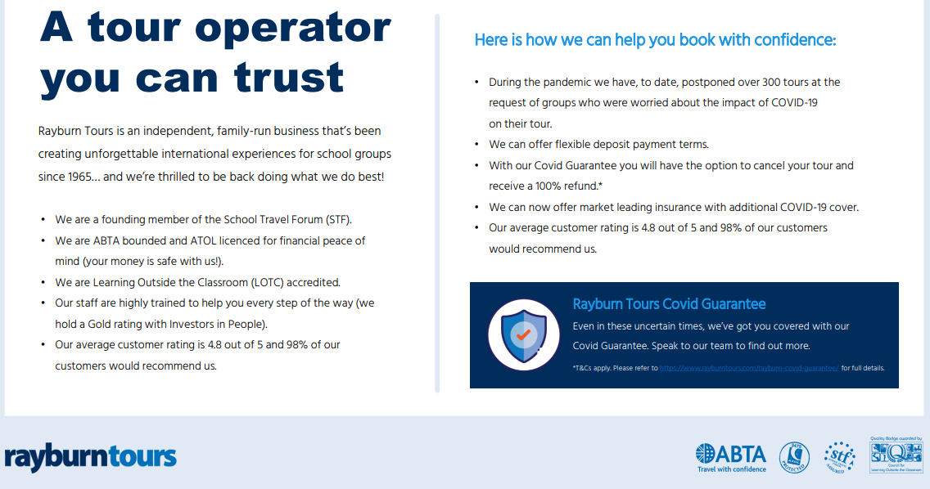

**Cost of the trip includes:**

Flights

* ATOL protected return flights in accordance to the available schedule. (Please note that flight routes, schedules, fares and availability are subject to confirmation at the time of booking.)
* 1 piece of hold and hand baggage per person, subject to weight and dimension restrictions.
* Low-Cost airline check-in and other charges (excluding excess baggage).
* All government and third-party taxes and charges.
* We have used an approximate flight rate of £292 per student and £305 per adult for your return flight. If this rate has increased by the time you book, flight supplements may be payable however we will discuss this with you before reconfirming any arrangements.

Coach Use

* Return transfers from your resort airport to your hotel in resort.
* All local road tolls and city entrance taxes.

Accommodation & Meal Arrangements

* 6 nights’ accommodation at Hotel Capitani.
* Adults to be accommodated in twin/triple rooms with en-suite facilities.
* Students to be accommodated in multi-bedrooms with en-suite facilities.
* Half board basis provided at your accommodation.
* Hot lunch at piste side restaurant.

Ski Elements

* 5 day local ski pass with no limitations
* 5 day ski hire including skis, boots, poles and helmets
* 6 local ski instructors dedicated to your group, each providing a minimum of 25 hours of instruction (5 hours per day)
* Convenient piste side equipment storage

Après ski Arrangements

* Rayburn Tours complimentary in-house après ski pack
* Final day presentation by the ski school with individual feedback cards and optional medals (additional charge)
* Additional après ski activities approx. £10 per activity e.g. ice skating, sledging.

Rayburn Representative

* Tour courier dedicated to your group only.

**Payment Plan:**

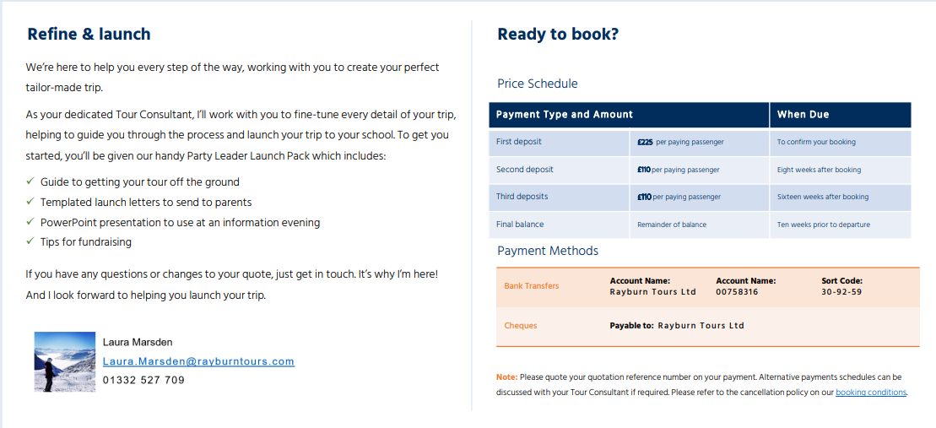

**Student funded trip**

**School to pay initial deposit to confirm the booking = £13,500 (60 x £225)**

|  |  |  |  |
| --- | --- | --- | --- |
| **Payment Schedule** | | | **Remaining Balance** |
| **By 8th April 2022** | **£60 deposit** | **Ski draw entry (students unsuccessful have deposits returned)** | **£1200** |
| **By 1st June 2022** | **£300** | **Payment 1** | **£900** |
| **By 15th August 2022** | **£300** | **Payment 2** | **£600** |
| **By 1st November 2022** | **£300** | **Payment 3** | **£300** |
| **By 1st February 2023** | **£300** | **Final Payment** | **£0** |

**Sample Itinerary:**

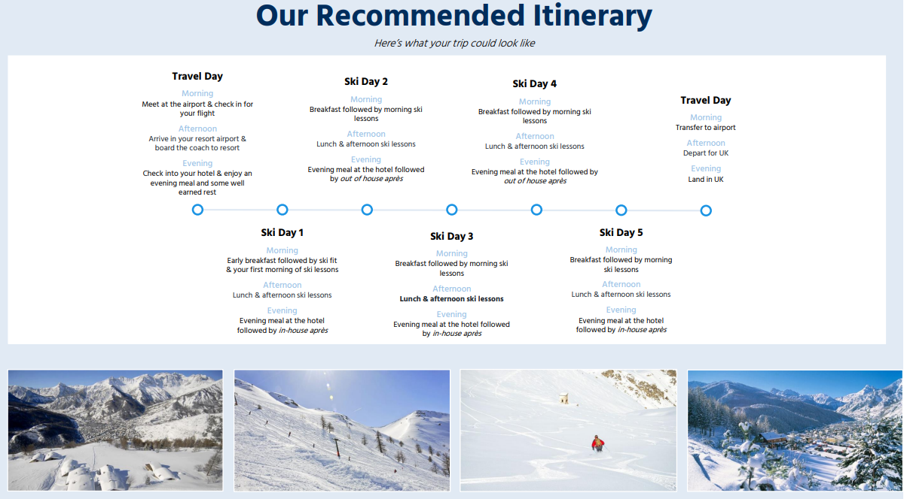

**Anticipated numbers of students (including DS)/staff involved:**

60 x students

Target current Yr8 and Yr9

Not first come first served. Window of application followed by a ‘ski draw’ for each year group

Specific cohorts, such as DS, can be allocated a place prior to the draw to ensure a strong representation.

7 x staff

Group Leader: James Endersby

Deputy Leader: Rachel Simpson

5 x additional staff TBC.

**Promotion of the visit:**

* Assembly Launch (w/c 21st March)
* Parent Pack Post Draw (w/c 18th April)
* Parents Information Evening (January 2023)
* ‘Ski Fit’ Circuit Sessions 6 x after school fitness sessions in the lead up to the trip. All students to attend, builds group culture and relationships

**Anticipated Timeline of Events:**

w/c 21st March: James Endersby / Rachel Simpson Yr8 and Yr9 assembly launch. Launch letters distributed.

Friday 8th April: £60 deposit deadline (through parent pay / set up with finance)

w/c 18th April: Ski Draw

Friday 22nd April: Parent Pack confirming places distributed to successful students.

Parent Mails: reminders of deadlines for payment schedule send out 2 weeks prior to deadline.

June 2022: Staffing confirmation and initial meeting.

September: Student meeting – updates and Hoodie launch.

December 2022: Full staff meeting and roles and responsibilities outlined by group leader.

January 2023: Full Parents Information Evening including ski clothing hire pitch (BAC Halifax).

February – March: Weekly ski fit sessions.

**Links to the Curriculum:**

Students’ personal development will be promoted throughout the trip by providing them with a rich set of experiences which will further develop their character and support their physical, social and mental well-being, see examples below:

* Enabling students to develop their self-knowledge, self-esteem and self-confidence through being taken out of their comfort zone, many being away from home for the first time.
* Enable students to learn a new adventurous activity in a phenomenal location within the Italian dolomites.
* Developing valuable understanding of another culture.
* Encourage students to develop self-regulation in terms of their behaviour, initiative and to understand how they can contribute positively to the lives of those within the school community by supporting others through an emotional and educational visit.
* Allow students to develop further tolerance and understanding of different cultures and traditions through acquiring an appreciation of and respect for another culture by visiting a foreign country.
* Encouraging respect for other people, from their peers, to their teachers, ski instructors and hotel staff and representatives.

**Information about our destinations:**

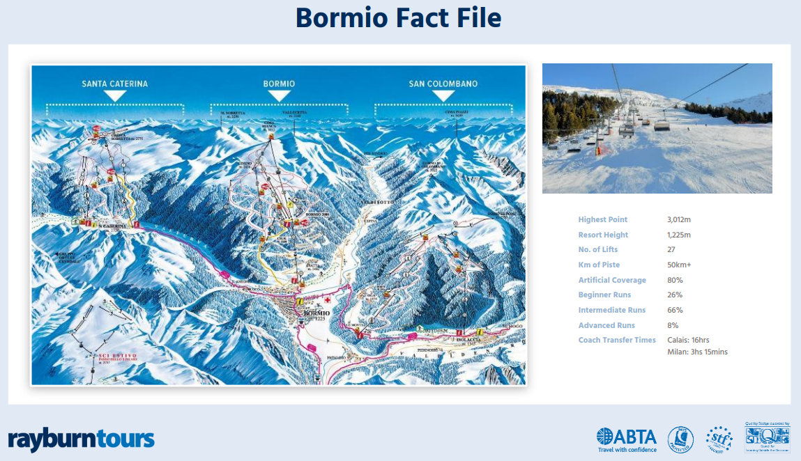

**Details of the hotel:**

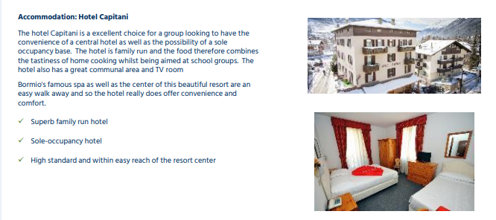

Bedroom doors can be locked so student’s valuables can be left throughout the day. Staff rooms are interspersed between student’s rooms for added security.

Students will have breakfast and evening meals in the hotel. Lunch will be on the mountain will be hot or cold within one of the après ski restaurants.

**Summary Comments:**

James Endersby has previous experience of leading trips within the UK and abroad. This includes 8 ski trips and 2 sports tours over the past 14 years.

Rachel Simpson also has prior experience of ski trips abroad.

All Rastrick risk assessments relevant to the trip will be reviewed and updated for the 2023 academic year.

Rayburn risk assessments and safety measures will be obtained and understood.

Regular planning meetings will ensure staff have a clear understanding of roles and responsibilities throughout the trip e.g. group leaders for registration.